LoRa Primer

* Radio goes from transmitter to receiver
* Transmitter has no knowledge of Receiver, where Receiver is, or if Receiver received the message
* Receiver does not know where the Transmitter is, only the signal strength (RSSI – received signal strength indicator)
* Frequency vs Wavelength (physics)
  + Long Wavelength = Low Frequency
    - Better penetration/range
    - Smaller bandwidth
  + Short Wavelength = High Frequency
    - Worse penetration/range
    - Larger bandwidth

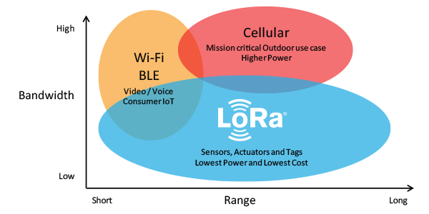

* Terms
  + Bandwidth – kHz of freq used to store data, more bandwidth = more data = faster transmission times (bigger is faster)
  + Coding Rate – every 4 out of X bits is actual data. If X is high, there is a lot of overhead = less data = longer transmission time (bigger is slower)
  + Spreading Factor – how spread out the data is, more spread out = longer transmission time (bigger is slower)
  + Power – signal power, more power means more penetration/range. Has no affect on transmission speed (bigger is better)
  + For the first three, lower transmission speed = better range/penetration
    - the trade off is speed vs range

Test Plan

* We are going to test various ranges and configurations (BW, Coding Rate, SF, Power)
* Default config: BW: 125kHz, SF: 7, Coding Rate: 5, Power: 17dBm
* All tests will go both ways
* Both radios have to have the same configs to work
* If you are lost type intro()

Test Steps

* Test Startup:
  + **Power up both Picos at the same time**
  + startLog(“4-1-21-adriano”)
    - change the name and date
* Across the room
  + logEntry(“Across the room – 4m”)
  + Standard Test:
    - defaultConfig()
    - sendTest() (Adriano once, Camille once)
    - speedConfig()
    - sendTest() (Adriano once, Camille once)
    - rangeCofig1()
    - sendTest() (Adriano once, Camille once)
    - rangeCofig2()
    - sendTest() (Adriano once, Camille once)
      * *if neither rangeConfig# work, enter setBoostPower(True) and try again*
* Desk to car
  + logEntry(“Desk to car - 40m”)
  + Standard Test
* Desk to leasing office, through buildings
  + logEntry(“Desk to office, through buildings – 140m”)
  + Standard Test
* Desk to Mill Rd merge
  + logEntry(“Desk to Mill Rd merge, through buildings – 370m”)
  + Standard Test
  + this will probably not work